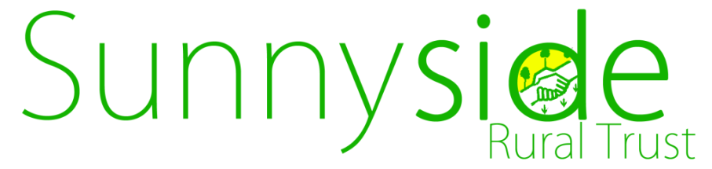

**PROJECT WORKER/GARDENER RECRUITMENT**

**Based in Northchurch, Berkhamsted and Hemel Hempstead**

Sunnyside Rural Trust is a registered charity offering training and employment opportunities to young people and adults with learning disabilities through horticulture. We have a number of social enterprises for trainees to gain work experience and paid employment. Across our services we grow a range of fruit, vegetables, herbs, plants including a large number of bedding plants for Dacorum Borough Council, coppice wood, conservation projects and we have 2 farm shops. We also look after pigs, sheep and chickens.

We are looking for new project workers to join us. You will be offering support to groups of young people and/or adults with learning disabilities to develop their work skills.

The ideal candidate will need to be enthusiastic and motivated. You will be working within a supportive team to deliver high quality services. Excellent communication, an open & inclusive working style and team working skills are essential. You will need a pragmatic and creative attitude with the skills to empower people. Horticultural skills are desirable, along with the ability to work outdoors in a horticultural environment. You will need to be willing and able to drive our minibuses and work vehicles.

Salary is dependent upon skills & experience and within SRT salary band **£17,686-£20,604 p.a.** We also offer a range of attractive staff benefits and great development opportunities. We will consider full and part time hours. Closing date 28.02.2020, interview date 11.03.2020.

For an application pack please contact [Lynn@sunnysideruraltrust.org.uk](mailto:Lynn@sunnysideruraltrust.org.uk)

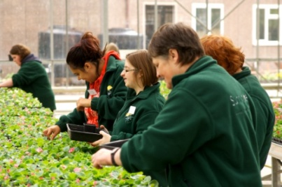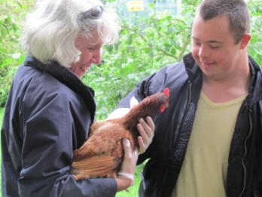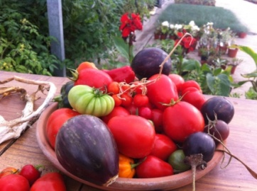

,

To learn more about what we do visit

**www.sunnysideruraltrust.org.uk**

Sunnyside Rural Trust is an equal opportunities employer.

We welcome and support applicants with disabilities.



cid:20D714A369E3DB44A400BBD24F72BE14@embltd.co.uk 