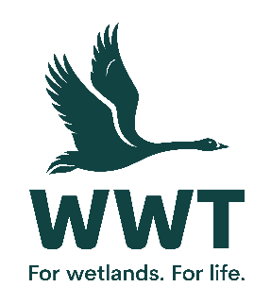
VOLUNTEER OPPORTUNITY: Term Time Toddler Activities Assistant
At the Wildfowl and Wetlands Trust we believe that the best way for people to understand and connect to wetlands is to experience them so we bring awe-inspiring nature up close. You will be directly involved in shaping our visitors’ unforgettable experiences through your warm welcome, your interaction with them and the information that you provide on the canoe safari and guided boat tours.
Volunteers play a crucial role in saving wetlands for wildlife and people.
This role involves:
These are some of the activities for the role, you may choose to do them all to develop your experience or just focus on one or two areas.
- Assisting the staff to give health and safety briefings covering all of the aspects of canoe safety applicable to Martin Mere canoe safari.
- Assisting with providing instruction and advice to visitors on using the canoe safely and to ensure buoyancy aids are fitted correctly paying particular attention to the sensitivities of older people and children. To ensure health and safety instructions and standards are strictly adhered to.
- Assisting the staff with handling money or taking credit card payments taken for canoe trips and boat tours.
- Driving the electric boat and providing an informative talk whilst driving
- Assisting the completion of paper work relevant to canoe trips accurately, in particular on participants return.
- Understanding the importance of prompt response to emergency calls.
- Monitoring the canoe route and visitors’ participation in the activity.
- Assisting with the cleanliness and Maintenance of canoe hut and surrounding area.
This role will suit you if:
No previous experience is required as training will be provided. However this role will suit you if you have a love of wildlife and the outdoors and are:
- Confident or experienced in talking to the public
- Able to work in a team of staff and volunteers
- Experienced in a visitor service environment with a strong commitment to excellent customer service
- Experience in canoeing is an advantage.
Practicalities
Where will you be based? Martin Mere Wetland Centre
Who will you volunteer with? A team of staff members and other volunteers
Time commitment? The canoe safari opens at 11am and closes at 4pm.
We want your volunteering to be a positive and fun experience. You’ll get a warm welcome, including information on training, equipment and other information you need. This will include risk assessments based on your role and any particular support you need.
Volunteers receive access to our sites, and discounts in our shops and cafes. Some roles include a uniform or require the use of equipment or protective clothing.
If you are based at a particular site or office location, you’ll need to be able to get yourself there and back. Information on locations can be found on our website.
If you are interested in volunteering for WWT but don't wish to apply online, please email volunteering@wwt.org.uk or leave a message at 01453 891 231 with your name and number.
We will keep you up to date with what’s happening across WWT and the difference you will be helping to make happen.
Interested?
If you are interested in this role, please complete an application form so that we can talk it through further with you.

